Practical no.1
Aim: Desing a class that store the information of STD and Display the same.
Program:
class xyz:
def display(self,sname,sage):
print("Name:",sname)
print("Age:",sage)
n=input("enter your name:\n")
a=int(input("enter your age:\n"))
x=xyz()
x.display(n,a)

Output:
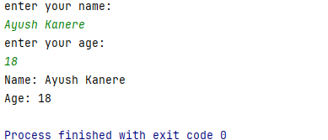

Practical no.2
Aim: Implement the concept of construction using python.
Program:
# Constructor in Python
class Student:
# Constructor
def __init__(self, name, age):
self.name = name
self.age = age
# Method to display details
def display(self):
print("Name:", self.name)
print("Age:", self.age)
# Creating an object
s1 = Student("Ayush", 18)
# Calling the method
s1.display()

Output:
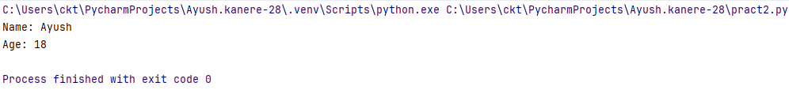

Practical no.3(A)
Aim: Implement the concept of inheritance
Program:
#Single inheritance
class A:
def a1(self):
print("Base Class")
class B(A):
def b1(self):
print("Derived class")
b=B()
b.a1()
b.b1()

Output:
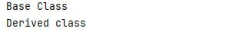

Practical no.3(B)
Aim: Multilevel inheritance.
Program:
#multilevel inheritance
class A:
def a1(self):
print("Class A")
class B(A):
def b1(self):
print("Class B")
class C(B):
def c1(self):
print("Class C")
c=C()
c.a1()
c.b1()
c.c1()

Output:
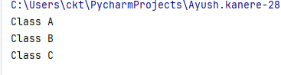

Practical no.3(c)
Aim: Multiple inheritance.
Program:
#multiple inheritance
class A:
a=10
class B:
b=20
class C(A,B):
def c1(self):
print("Addition=",A.a+B.b)
c=C()
c.c1()

Output:
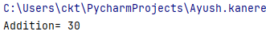

Practical no.4
Aim: Implement the concept of method overriding using python.
Program:
#implentation of concept of method overriding using python
class A:
def show(self):
print("Base Class ")
class B(A):
def show(self):
print("Derived Class ")
b=B()
b.show()
#call the method of class A
a=A()
a.show()

Output:
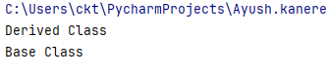

Practical no.5(A)
Aim: Write a program to implement layout management.
#Pack Layout
Program:
from tkinter import *
win=Tk()
l1=Label(win,text="1st No").pack()
e1=Entry(win,bd=5).pack()
l2=Label(win,text="2nd No").pack()
e2=Entry(win,bd=5).pack()
b=Button(win,text="Addition").pack()
l3=Label(win,text="Total").pack()
e3=Entry(win,bd=5).pack()
win.geometry("250x250+10+10")
win.mainloop()

Output :
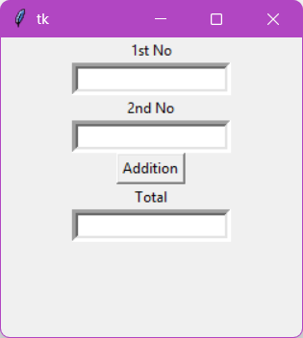

Practical no.5(B)
Aim: write a program to implement layout management.(Place layout)
Program:
import tkinter as tk
root=tk.Tk()
root.title("Place Layout")
root.geometry("400x300")
l1=tk.Label(root,text="Username: ",font=("Helvetica",12))
l1.place(x=50,y=50)
e1=tk.Entry(root,width=20)
e1.place(x=150,y=50)
b1=tk.Button(root,text="Submit", width=10)
b1.place(x=150,y=100)
root.mainloop()

Output:
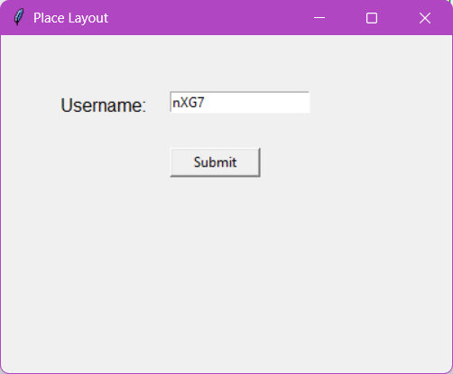

Practical no.5(C)
Aim: write a program to implement layout management.(Grid layout)
Program:
import tkinter as tk
root=tk.Tk()
root.title("Grid layout example")
root.geometry("300x150")
l1=tk.Label(root,text="Username:")
e1=tk.Entry(root)
l2=tk.Label(root,text="Password:")
e2=tk.Entry(root, show="*")
b1=tk.Button(root,text="Login")
l1.grid(row=0,column=0, padx=10, pady=5, sticky="e")
e1.grid(row=0, column=1, padx=10, pady=5)
l2.grid(row=1, column=0, padx=10, pady=5, sticky="e")
e2.grid(row=1, column=1, padx=10, pady=5)
b1.grid(row=2, column=0, columnspan=2, pady=10)
root.mainloop()

Output:
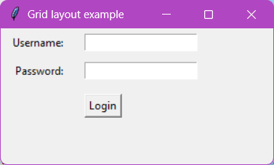

Practical no.6
Aim: Write a program to configure the widget with various option like: “bg = “red”, family=”Times”, size=18
Program:
import tkinter as tk
win=tk.Tk()
win.title("Practical 6")
def redClick():
label.configure(text="Times New Roman Font ", bg="red", font=("Times",18))
def greenClick():
label.config(text="Calibri (Body) Font")
label.config(bg="Green")
label.config(font=("Helvetica",18))
label=tk.Label(win,text="Practical 6", bg="white")
label.pack()
b1=tk.Button(win,text="red click",command=redClick).pack(side="left")
b2=tk.Button(win,text="Green click",command=greenClick).pack(side="left")
win.mainloop()

Output:
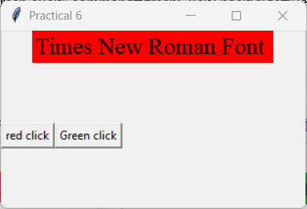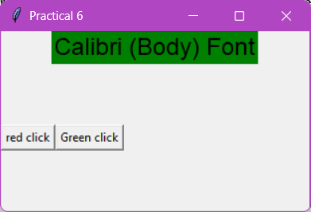

Practical no.7
Aim: Design a registration Page using widgets.
Program:
import tkinter as tk
from tkinter import messagebox
root = tk.Tk()
root.title("User Registration")
root.geometry("400x300")
def register_user():
username= username_entry.get()
email=email_entry.get()
password= password_entry.get()
confirm_password= confirm_password_entry.get()
if not username or not email or not password or not confirm_password:
messagebox.showerror("Resgistration Error", "Please fill all three fields")
return
if password != confirm_password:
messagebox.showerror("Resgistration Error", "Passwords do not match")
return
messagebox.showinfo("Registration Success",f"user '{username}' Registration Successfull")
username_entry.delete(0,tk.END)
email_entry.delete(0,tk.END)
password_entry.delete(0,tk.END)
confirm_password_entry.delete(0,tk.End)
username_label =tk.Label(root,text="Usrname")
username_label.place(x=50,y=50)
username_entry= tk.Entry(root)
username_entry.place(x=150,y=50, width=200)
password_label= tk.Label(root,text="Password:")
password_label.place(x=50,y=90)
password_entry= tk.Entry(root, show="*")
password_entry.place(x=150,y=90, width=200)
confirm_password_label =tk.Label(root,text="Confirm PAssword:")
confirm_password_label.place(x=50,y=130)
confirm_password_entry= tk.Entry(root, show="*")
confirm_password_entry.place(x=150,y=130, width=200)
email_label=tk.Label(root,text="Email:")
email_label.place(x=50,y=170)
email_entry=tk.Entry(root)
email_entry.place(x=150,y=170, width=200)
register_button=tk.Button(root,text="Register",command=register_user)
register_button.place(x=150,y=210, width=200)
root.mainloop()
Output:
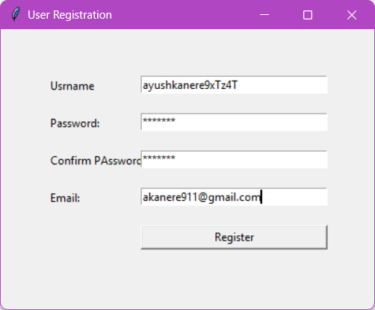
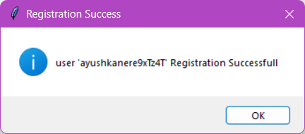
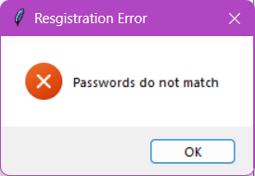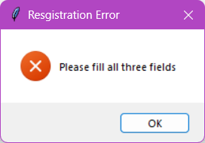
Practical no.8
Aim: Design a program to implement Calculator using tkinter.
Program :
from tkinter import *
expr = "" # Global expression string
def press(key):
global expr
expr += str(key)
display.set(expr)
def equal():
global expr
try:
result = str(eval(expr))
display.set(result)
expr = ""
except:
display.set("error")
expr = ""
def clear():
global expr
expr = ""
display.set("")
if __name__ == "__main__":
root = Tk()
root.configure(bg="light gray")
root.title("Simple Calculator")
root.geometry("270x150")
display = StringVar()
entry = Entry(root, textvariable=display)
entry.grid(columnspan=4, ipadx=70)
# Number buttons
btn1 = Button(root, text='1', fg='black', bg='white', command=lambda: press(1), height=1, width=7)
btn1.grid(row=2, column=0)
btn2 = Button(root, text='2', fg='black', bg='white', command=lambda: press(2), height=1, width=7)
btn2.grid(row=2, column=1)
btn3 = Button(root, text='3', fg='black', bg='white', command=lambda: press(3), height=1, width=7)
btn3.grid(row=2, column=2)
btn4 = Button(root, text='4', fg='black', bg='white', command=lambda: press(4), height=1, width=7)
btn4.grid(row=3, column=0)
btn5 = Button(root, text='5', fg='black', bg='white', command=lambda: press(5), height=1, width=7)
btn5.grid(row=3, column=1)
btn6 = Button(root, text='6', fg='black', bg='white', command=lambda: press(6), height=1, width=7)
btn6.grid(row=3, column=2)
btn7 = Button(root, text='7', fg='black', bg='white', command=lambda: press(7), height=1, width=7)
btn7.grid(row=4, column=0)
btn8 = Button(root, text='8', fg='black', bg='white', command=lambda: press(8), height=1, width=7)
btn8.grid(row=4, column=1)
btn9 = Button(root, text='9', fg='black', bg='white', command=lambda: press(9), height=1, width=7)
btn9.grid(row=4, column=2)
btn0 = Button(root, text='0', fg='black', bg='white', command=lambda: press(0), height=1, width=7)
btn0.grid(row=5, column=0)
# Operator buttons
plus = Button(root, text='+', fg='black', bg='white', command=lambda: press('+'), height=1, width=7)
plus.grid(row=2, column=3)
minus = Button(root, text='-', fg='black', bg='white', command=lambda: press('-'), height=1, width=7)
minus.grid(row=3, column=3)
mult = Button(root, text='*', fg='black', bg='white', command=lambda: press('*'), height=1, width=7)
mult.grid(row=4, column=3)
div = Button(root, text='/', fg='black', bg='white', command=lambda: press('/'), height=1, width=7)
div.grid(row=5, column=3)
# Other buttons
eq = Button(root, text='=', fg='black', bg='white', command=equal, height=1, width=7)
eq.grid(row=5, column=2)
clr = Button(root, text='Clear', fg='black', bg='white', command=clear, height=1, width=7)
clr.grid(row=5, column=1)
dot = Button(root, text='.', fg='black', bg='white', command=lambda: press('.'), height=1, width=7)
dot.grid(row=6, column=0)
root.mainloop()

Output:
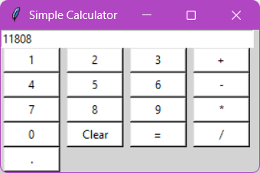

Practical no.9
Aim: Design a simple database application that stores the records and retrieve the same & search the specified record from the database
Program:

Practical no 11
Practical no.11
Aim: write a program for creation of vectors and matrices using numpy
# Vector
Program :
#Vector
import numpy as np
list=[10,20, 30,40,50]
vtr=np.array(list)
print("list=",list)
print("vector form list =",vtr)
list2=[[12],
[20],
[30],
[40]]
vtr2=np.array(list2)
print("Verticle vector form list =\n",vtr2)
#Matrix
import numpy as np
a=np.matrix('1 2;3 4')
b=np.matrix([[10, 20],[30, 40]])
print("matrix [a]=\n",a)
print(b)

Output:
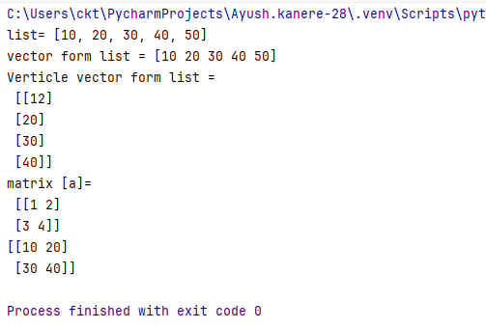
Practical no.12
Aim: write a program to develop pandas data structure ( Series and dataframe)

Program :
import numpy as np
import pandas as pd
ages = np.array([13,25,19])
print("ages in vector= \n",ages)
series1= pd.Series(ages)
print("ages in pandas series format=")
print(series1)
dataf = pd.DataFrame( [
['Ayush','Panvel',21],
['Ansh','Uran',22],
['Manish','Pen',23]
],
columns=['name','address','age'])
print("matrix data in Dataframe format=")
print(dataf)

output:
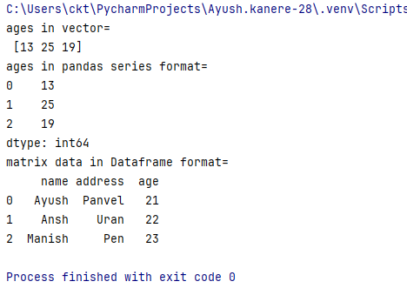

Practical no.13
Aim: Write a program for data wrangling using pandas
Program:
import pandas as pd
#Assign data
data= {'name':['Ayush','Manish','Ansh','brijesh','Parth','Nihal','Soham'],
'Age': [18,18,17,18,19,17,17],
'Gender':['M','M','M','M','M','M','M'],
'Marks':[90,99,98,97,99,94,96]}
#Convert into Dataframe
df = pd.DataFrame(data)
#Display data
print(df)

Output:
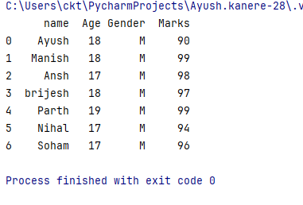

Practical no. 14
Aim: Write a python to design Scatter, Line and Box Plot using matplotlib.
Program:
#Scatter plot
import matplotlib.pyplot as plt
x=[4,5,7,9,8]
y=[25,60,90,34,55]
plt.scatter(x,y,color='pink')
#show the plot
plt.show()

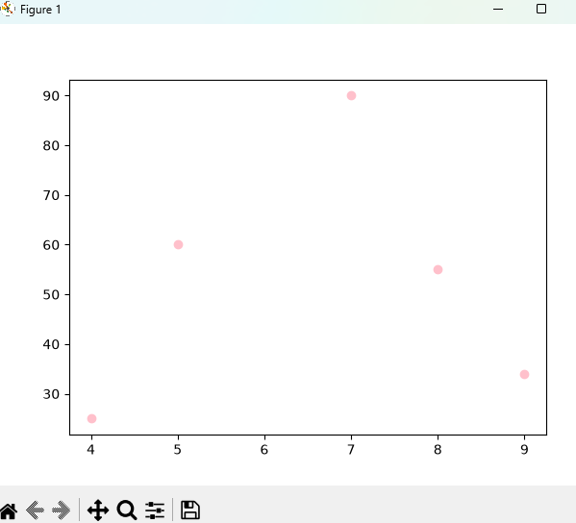

#Line plot
import matplotlib.pyplot as plt
import numpy as np
x = np.array([1,2,3,4])
y= x * 2
plt.subplot(1,2,1)
plt.plot(x,y)
plt.xlabel('x-axis')
plt.ylabel('y-axis')
plt.title("Any subtitle")
plt.subplot(1,2,2)
plt.plot(x,y,'-.')
plt.xlabel('x-axis')
plt.ylabel('y-axis')
plt.title("Any subtitle")
plt.show()

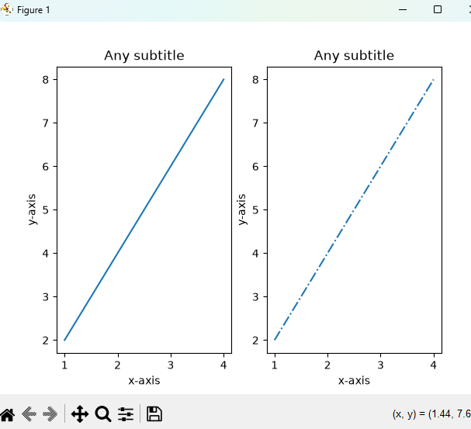

# Box Plot
import pandas as pd
import matplotlib.pyplot as plt
df = pd.DataFrame({
'Age':[20,30,40,50,111],
'Group':['A','B','A','B','A']
})
#plot instantly grouped by a specific column
df.boxplot(column='Age',by='Group')
plt.show()

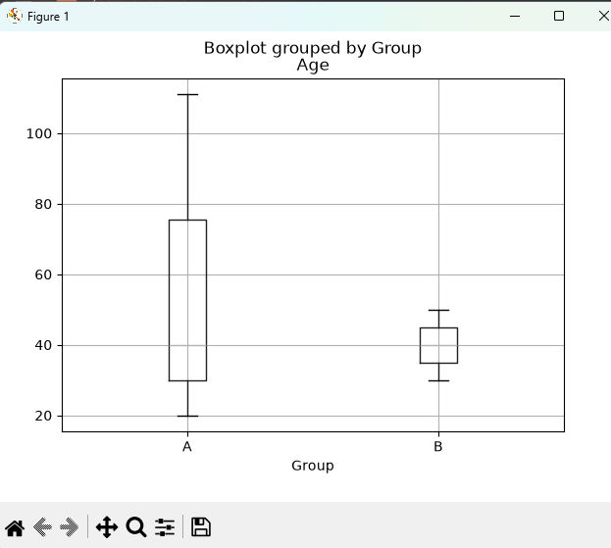

Practical no 15
Aim: write a program to design Histogram and Bar chart using Matplotlib

#bar chart

Program:
import matplotlib.pyplot as plt
#creating the data set
data ={'c':20,'c++':30,'Java':45,'Python':48}
courses = list(data.keys())
values = list(data.values())
pig = plt.figure(figsize= (10,10))
#creating the bar plot
plt.bar(courses,values,color='pink', width=0.2)
plt.xlabel("Courses offered")
plt.ylabel("No. of students enrolled")
plt.title("Students enrolled in different courses")
plt.show()

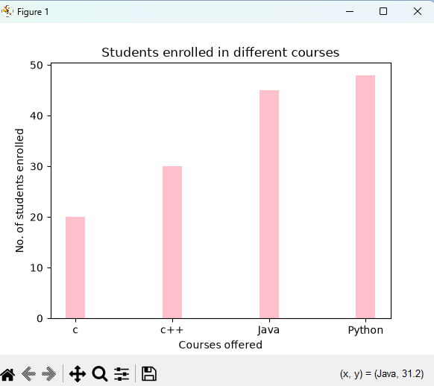

# Histogram
import matplotlib.pyplot as plt
import numpy as np
#generate random data for the hoistogram
data = np.random.random(1000)
#ploting a basic histogram
plt.hist(data, bins=30,color='pink', edgecolor='black')
#Adding lables and title
plt.xlabel('Values')
plt.ylabel('Frequency')
plt.title('Basic Histogram')
#Display the plot
plt.show()

Output:

